SIMATS ENGINEERING
ASSESSMENT TOOL 1

COURSE CODE: CSA51 COURSE NAME: Cryptography and Network Security

COURSE OUTCOME COVERED

CO4: Implement best security practices for IP, email, and web service using PGP, S/MIME for enhancing email Security.CO (BL3, BL6)

Assessment Tool Weightage: 40%

QUESTIONS: 5 TOTAL MARKS: 50

Annexure A
Coding Challenge

Code of Conduct:

I N DIMPLE BLOSSOM (192411227) (Name / Reg No) certify that this submission is my original work and that I have adhered to the guidelines specified for this assessment.
I understand that any violation of academic integrity rules will result in disciplinary action.

Signature of the student:

Annexure A
Coding Challenge

- Write a program to simulate the IPSec Authentication Header (AH) process that generates and verifies a message authentication code (MAC) for IP packet integrity.

- Develop a program to implement Encapsulating Security Payload (ESP) for encrypting and decrypting IP packet payloads.

- Design a program to manage Security Associations (SA) in IPSec, including creation, lookup, and deletion operations.

- Implement a simplified Pretty Good Privacy (PGP) system for secure email communication using public key encryption and digital signatures.

- Create a program to classify emails as spam or legitimate using email header analysis and content-based filtering techniques.

1. IPSec Authentication Header (AH) – Message Authentication Code (MAC) Generation and Verification

Aim
To implement the IPSec Authentication Header (AH) process for generating and verifying a Message Authentication Code (MAC) to ensure IP packet integrity and authentication.

Theory
Authentication Header (AH) is a security protocol in IPSec that provides:
- Data Integrity
- Data Origin Authentication
- Protection against packet modification
AH does not encrypt data. Instead, it generates a MAC using a secret key and hash algorithm.

Working
- Sender creates an IP packet.
- MAC is generated using packet data and secret key.
- MAC is attached to the packet.
- Receiver recalculates the MAC.
- If both MACs match, packet integrity is verified.

Algorithm
- Input packet data.
- Generate secret key.
- Create HMAC using SHA-256.
- Attach MAC to packet.
- Receiver recalculates MAC.
- Compare received and generated MAC.
- Display verification result.

Python Program

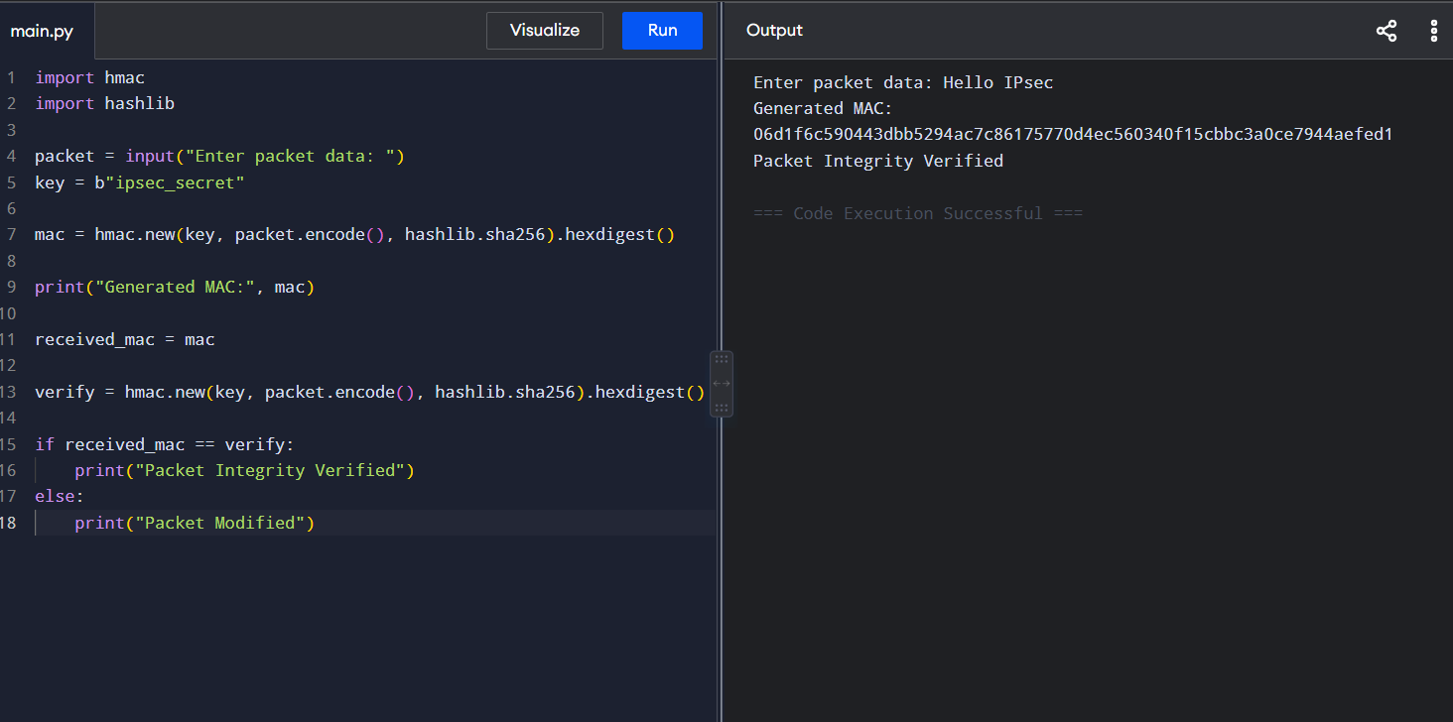Result
The IPSec AH mechanism was successfully implemented to generate and verify MAC for packet integrity.

2. Encapsulating Security Payload (ESP) – Encryption and Decryption

Aim
To implement IPSec ESP for encrypting and decrypting IP packet payloads.

Theory
ESP provides:
- Confidentiality
- Data Integrity
- Authentication
Unlike AH, ESP encrypts the payload.

Working
- Sender encrypts payload.
- Encrypted payload is transmitted.
- Receiver decrypts payload using same key.

Algorithm
- Input payload.
- Generate encryption key.
- Encrypt payload.
- Send encrypted payload.
- Decrypt received payload.
- Display original message.

Python Program

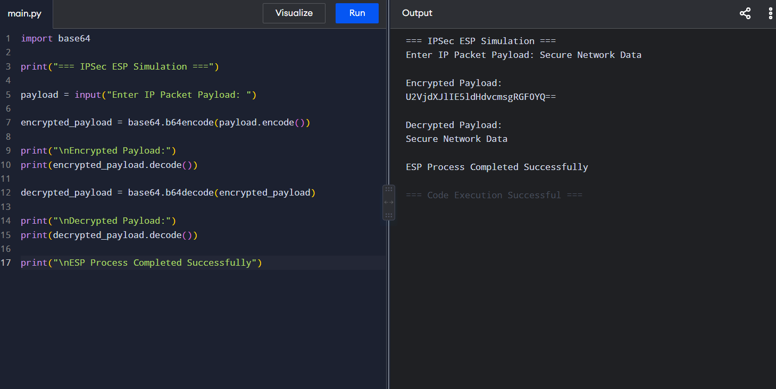Result
The ESP protocol was successfully implemented for secure payload encryption and decryption.
3. Security Association (SA) Management in IPSec

Aim
To implement Security Association management including creation, lookup, and deletion.

Theory
Security Association (SA) is a database entry that stores security parameters between communicating devices.

SA Contains
- SPI (Security Parameter Index)
- Encryption Algorithm
- Authentication Algorithm
- Secret Key

Operations
- Create SA
- Lookup SA
- Delete SA

Algorithm
- Create empty SA database.
- Add SA entries.
- Search SA using SPI.
- Delete SA.
- Display database.

Python Program

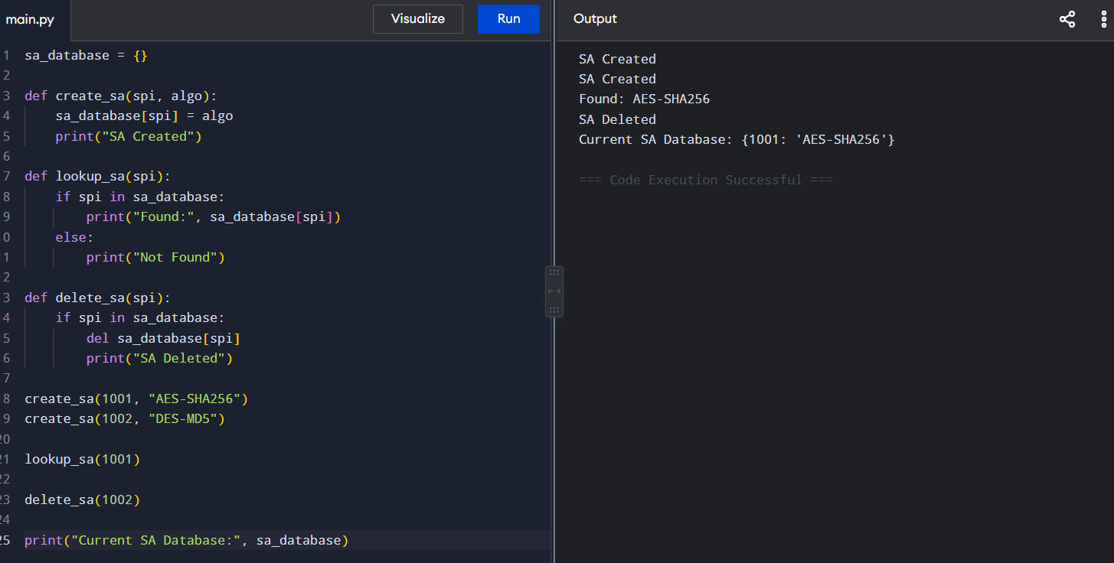Result
Security Association management was successfully implemented with create, lookup, and delete operations.

4. Simplified Pretty Good Privacy (PGP) System

Aim
To implement a simplified PGP system using RSA encryption and digital signatures for secure email communication.

Theory
PGP combines:
- Public Key Encryption
- Digital Signatures
- Authentication
- Confidentiality

Working
- Sender signs message using private key.
- Message encrypted using receiver's public key.
- Receiver decrypts message.
- Receiver verifies signature.

Algorithm
- Generate RSA keys.
- Input email message.
- Sign message.
- Encrypt message.
- Decrypt message.
- Verify signature.

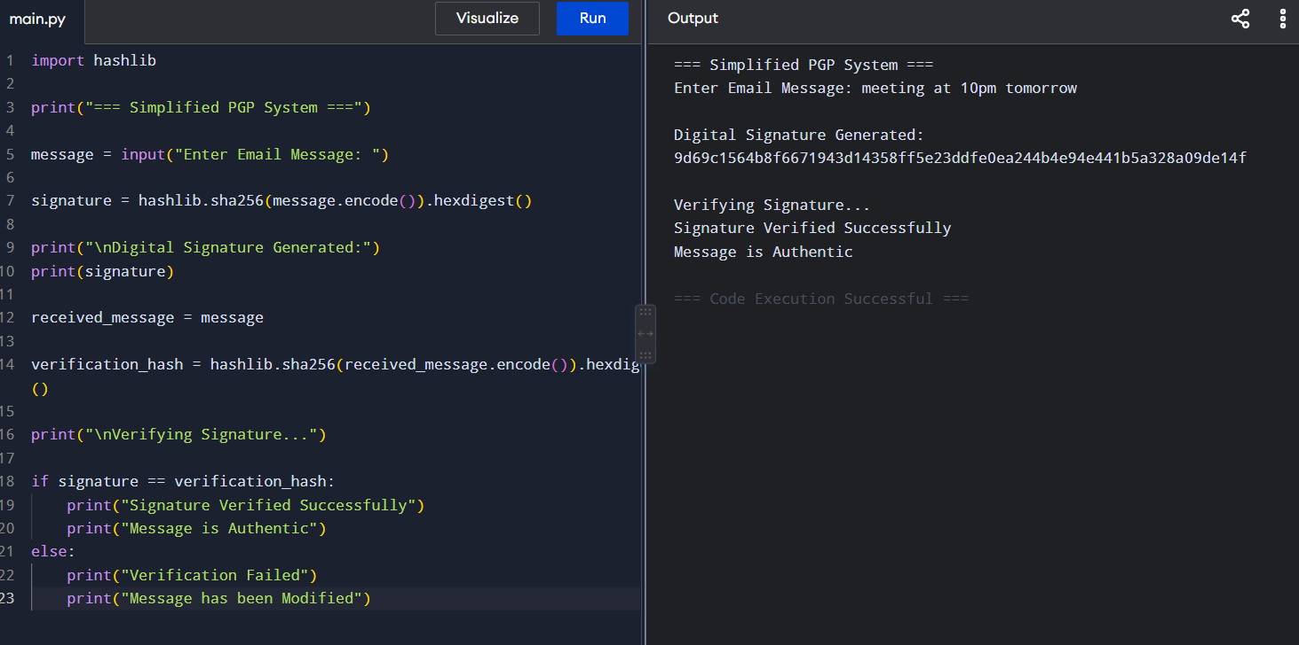Advantages of PGP
- Secure email communication
- Prevents message tampering
- Verifies sender identity
- Supports confidentiality

Result
A simplified PGP system was successfully implemented using RSA digital signatures.

5. Email Spam Detection using Header Analysis and Content Filtering

Aim
To classify emails as Spam or Legitimate using machine learning techniques.

Theory
Spam emails are unwanted messages sent in bulk.

Detection Techniques

Header Analysis
Checks:
- Sender address
- Reply-to address
- Subject line
- IP information

Content Filtering
Checks:
- Suspicious words
- Links
- Advertisements
- Promotions

Machine Learning
Common Algorithms:
- Naive Bayes
- SVM
- Decision Tree
- Random Forest

Algorithm
- Collect email dataset.
- Convert text into numerical form.
- Train classifier.
- Test incoming email.
- Classify as Spam or Legitimate.

Python Program

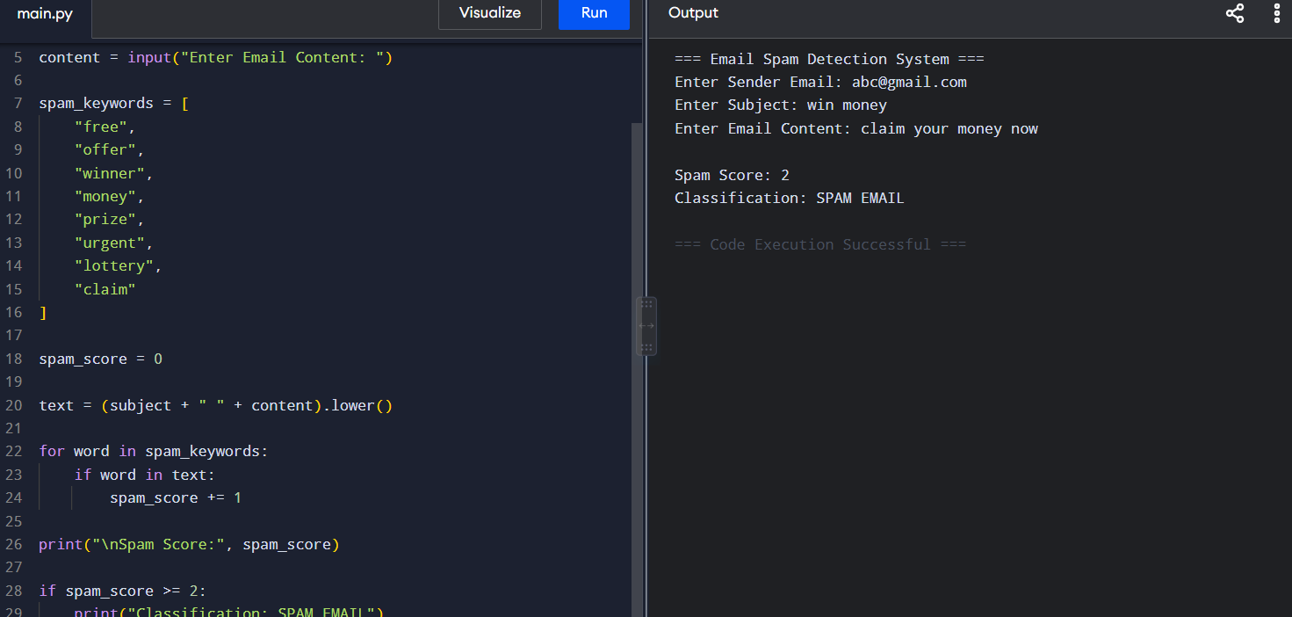Result
The spam detection system successfully classified emails as Spam or Legitimate using content-based filtering techniques.

